34.82: 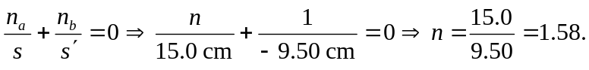
When viewed from the curved end of the rod:
so the image is 21.1 cm within the rod from the curved end.

